Asynchronous service in Microsoft Dynamics CRM:
The asynchronous service executes long-running operations independent of the main Microsoft Dynamics CRM 2015 and Microsoft Dynamics CRM Online 2015 Update core operation. This results in improved overall system performance and improved scalability. The asynchronous service features a managed queue for the execution of asynchronous registered plug-ins, workflows, and operations such as bulk mail, bulk import, and campaign activity propagation. These operations are registered with the asynchronous service and executed periodically when the service processes its queue. The asynchronous service can be hosted on a server other that the server running Microsoft Dynamics CRM
Asynchronous operations are spawned to handle many types of Microsoft Dynamics CRM operations, for example import/export, bulk operations, duplicate detection, recurring appointments, recurring (internal) system jobs, and more.

This results in improved overall system performance and improved scalability. The asynchronous service features a managed queue for the execution of asynchronous registered plug-ins, workflows, and operations such as bulk mail, bulk import, and campaign activity propagation. These operations are registered with the asynchronous service and executed periodically when the service processes its queue. The asynchronous service can be hosted on a server other that the server running Microsoft Dynamics CRM.

A system job, also known as an asynchronous operation, is used to define and track the execution of an asynchronous operation, for example an asynchronous registered plug-in, workflow, or other background system operation. When dealing with asynchronous plug-ins and workflows, you typically don’t create an asyncoperation entity record directly. Instead, an asyncoperation record is automatically created in the database whenever an asynchronous system operation, such as an asynchronous plug-in or a workflow, is going to run. However, you can use the asyncoperation entity when you develop custom tools to manage or report on asynchronous operations in Microsoft Dynamics CRM.
Note that System Job is the display name of this entity when you view it in CRM. When you program by using the Microsoft Dynamics CRM SDK, you use the asyncoperation logical name.

An asynchronous operation (system job) represents a process whose execution can continue independently or in the background. The schema name for this entity is AsyncOperation. To view the entity metadata for your organization, install the Metadata Browser solution described in Browse the metadata for your organization. You can also view the metadata for an uncustomized organization in the Excel file called EntityMetadata.xlsx included in the top-level folder of the SDK download.
The following table describes the messages for this entity, which you use with theIOrganizationService.Execute method.

Message | Description
CreateRequest | For internal use only.
DeleteRequest | Deletes an asynchronous operation (system job). The asynchronous operation can be deleted only if the AsyncOperation.AsyncOperationState is Completed. You can also call the IOrganizationService.Delete method.
RetrieveRequest | Retrieve an asynchronous operation (system job). You can also call the IOrganizationService.Retrieve method.
RetrieveMultipleRequest | Retrieves a collection of asynchronous operations (system jobs). You can also call the IOrganizationService.RetrieveMultiple method.
RetrievePrincipalAccessRequest | Retrieves the access that the security principal (user) has for an asynchronous operation (system job).
UpdateRequest | Updates an asynchronous operation (system job). Typically, you would update only the AsyncOperation.StateCode or AsyncOperation.PostponeUntil attributes of the asynchronous operation (system job). You can also call the IOrganizationService.Update method.

States for asynchronous operations
The state of the asynchronous operation can be altered through three means: by the platform as part of regular queue processing, by the user interacting with the Microsoft Dynamics CRM Web application, or by a Web service call that alters the asynchronous operation. As a developer you can retrieve the current state of any asynchronous operation that you have access to and also change the state.
The following table lists the states, and the statuses for each state, of an AsyncOperation.

State | Status | Numeric status value
Ready | WaitingForResources | 0
Suspended | Waiting | 10
Locked | InProgress | 20
Locked | Pausing | 21
Locked | Canceling | 22
Completed | Succeeded | 30
Completed | Failed | 31
Completed | Canceled | 32

The supported states are defined in the AsyncOperationState enumeration. In the early bound AsyncOperation class, the state is available in the AsyncOperation.StateCode attribute while the status is available in the AsyncOperation.StatusCode attribute.
Monitoring and updating the state of an asynchronous operation is typically done interactively through the System Jobs grid in the Microsoft Dynamics CRM Web application.

Read the state of an asynchronous operation

- Retrieve an AsyncOperation by name using the RetrieveMultiple method or by ID using the Retrieve method.
- Read the AsyncOperation.StateCode attribute.

Change the state code

- Modify the retrieved state code attribute to a new value according to the allowed operation states. You could also change the AsyncOperation.PostponeUntil attribute.
- Call Update to change the value of those attributes in the database.
Dependency and execution order in asynchronous operations
https://msdn.microsoft.com/en-us/library/gg327994.aspx
For Microsoft Dynamics CRM on-premises (including IFD) deployments, the asynchronous service can be stopped and restarted by using the Services administrative tool. The service should be stopped before a plug-in assembly that contains asynchronous plug-ins is deleted.
Detect duplicate data: https://msdn.microsoft.com/en-us/library/gg309427.aspx
How to delete the completed workflows
http://www.powerobjects.com/2014/04/24/missing-dynamics-crm-2013-workflow/
http://www.powerobjects.com/2011/10/28/how-to-create-a-microsoft-dynamics-crm-workflow-notification-that-is-based-on-the-number-of-days-that-the-record-has-been-opened/

How to create a Microsoft Dynamics CRM workflow notification that is based on the number of days
There are four options provided to define your scope:
- User
- Business Unit
- Parent: Child Business Units
- Organization
Much like security access levels Microsoft Dynamics CRM provides for users, the scope allows for constraints on the records to be affected by the process. Workflow scope will execute primary to the user’s security rights and secondary to the workflow scope. In other words, scope of a workflow will not alleviate the user security rights, but only create additional restrictions on the records affected.
By selecting User as the scope, only the records owned by the current user are affected by the process even if the user has organizational-level access rights. By selecting Business Unit as the scope, the workflow will only execute for the user’s Business unit. Selecting Parent: Child Business Units as the scope will execute on records in the user’s business unit and records with ownership in a child business unit of the user’s business unit. Finally, by selecting Organization as the scope, the workflow will execute on any record in the organization secondary to the user’s security rights.
Under the Microsoft Dynamics CRM Security Role, Customization tab, there is a "Workflow" entity to set security privileges on. This setting controls the Workflow privileges for CRM Users assigned to this security role
For example – if the Automatic Workflow scope is "User" – only the CRM records owned by the Workflow’s Owner will be triggered if it meets the Workflow’s automatic condition. If the setting is "Organization" – any CRM records could trigger the Workflow if they meet the Workflow’s automatic condition.
We can also leverage the Microsoft CRM Record Sharing function to share the Workflow to each of the selected CRM users or to the CRM team that consists of the selected CRM users
Below is the important blog:
http://www.magnetismsolutions.com/blog/colinmaitland/2014/06/22/microsoft-dynamics-crm-2013-automatically-triggered-background-workflow-processes-scope
Examples
http://www.zero2ten.com/blog/3-must-know-workflows-in-microsoft-dynamics-crm-2011/
CRM 2011 - How to use Wait/Timeout in Workflows?
One of the great benefits of Microsoft Dynamics CRM, is that is has built-in support for creating Workflows. Creating a workflow involves defining a sequence of steps that describes what the workflow process should do, and when it should do it.

Often you will need to pause the execution of a workflow until a specific condition is met. To achieve this you will want to use a Wait Condition, which can be broken down into the following:
- Wait - use this to wait until a condition is met, examples of this could be when a Record Status changes, a field is updated or a value on a related Record is changed
- Timeout - use this to wait until a specific date, a period of time or a date relative to a field in a record e.g. 5 days after the Record Created Date
Example Background
We want to use Workflows to create a phone call activity so that someone from our sales department can follow up on newly created leads. When a user completes the activity we want to track if the lead has been contacted. If the lead has not been contacted within 7 days, we want to re-assign the lead to the 2nd line Sales team.

For simplicity we will create two workflows to achieve this.

Wait in a Workflow
When a lead is created, it will trigger a workflow to create an associated Phone Call activity and wait until the activity is complete, once complete the workflow will update the "Status Reason" field on the Lead as "Contacted".
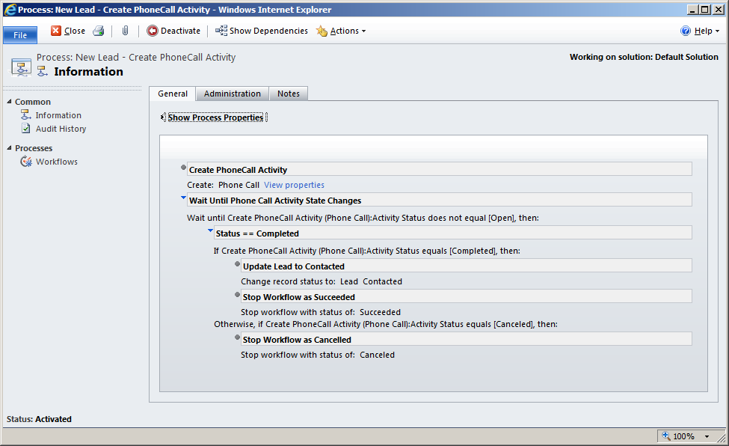

Timeout in a Workflow
When a lead is created, the Workflow will pause for exactly 7 days from when the Lead was created, when the timeout is reached the workflow will check if the Lead's "Status Reason" field is set to "New", if yes then the Lead will be re-assigned to the "Sales 2nd Line" Team.
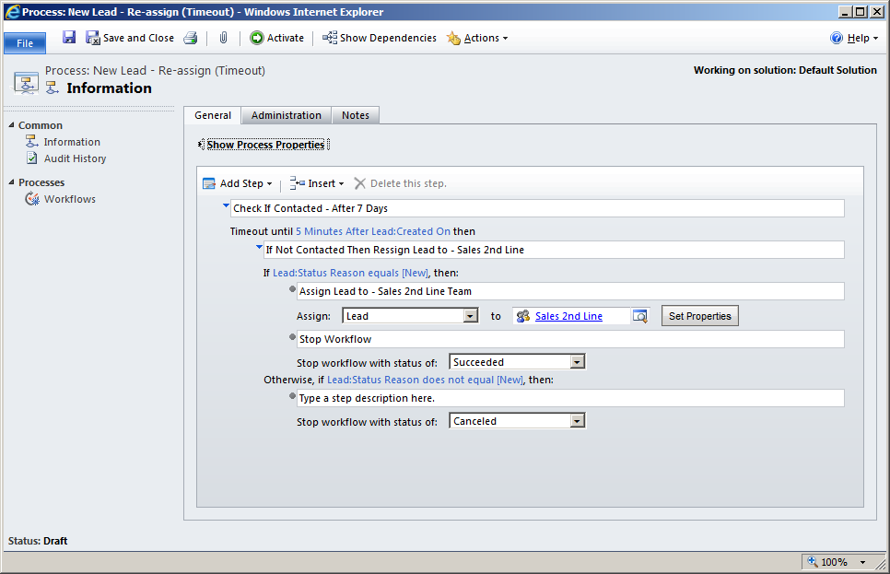
Hopefully Wait and Timeouts now make a little more practical sense.
http://social.technet.microsoft.com/wiki/contents/articles/11291.microsoft-dynamics-crm-2011-workflows-wait-and-timeout.aspx
http://www.magnetismsolutions.com/blog/paulnieuwelaar/2012/11/25/workflow-wait-conditions-best-practices-dynamics-crm-2011
Waits and Timeouts in Dynamics CRM Workflows When to Wait, When to Timeout
http://rahuljim.blogspot.in/2013/06/waits-and-timeouts-in-dynamics-crm.html
Timeout Workflow:
https://community.dynamics.com/crm/f/117/t/104934
https://markuserlandsson.wordpress.com/2010/09/06/workflow-timeout/
Tip #121: Don’t use wait conditions
http://crmtipoftheday.com/2014/04/28/dont-use-wait-conditions/

